CSE 581

**Lab 2: Basic Selects**

*Do this lab against the Northwind database.*

***For the entire lab, provide all of your SQL as text, inserted at the beginning of the document.***

***For each step also provide a screenshot of execution, showing the SQL and the results.***

***Please make sure both the SQL and the screenshots are marked w/ the question number that they are answering.***

**Steps:**

1. Select all data from the Order Details table.

SELECT *

FROM [ORDER DETAILS];

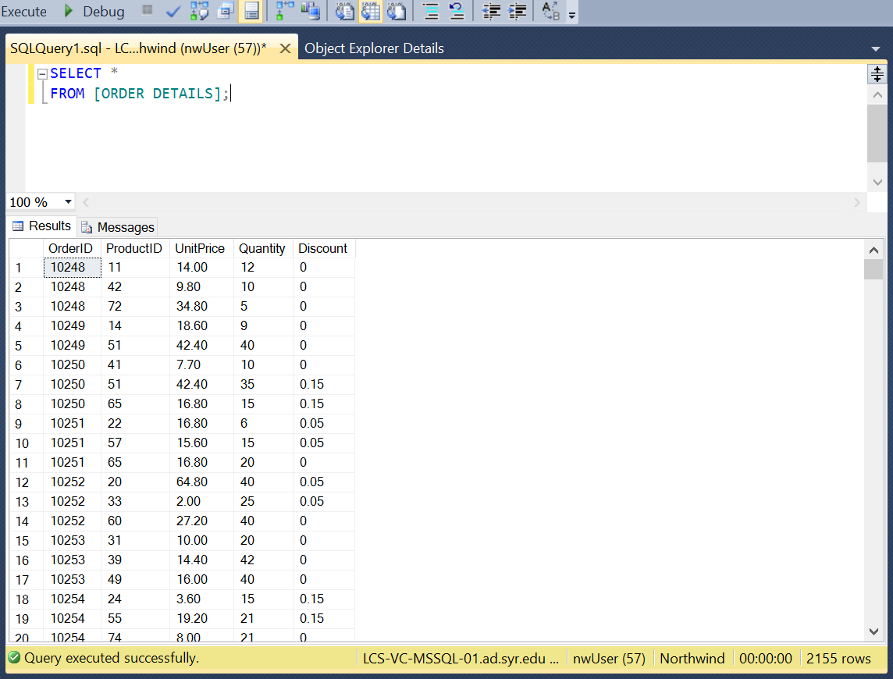

1. Select all data from the Customers table, ordered by **ContactName**.

SELECT *

FROM CUSTOMERS

ORDER BY CONTACTNAME;

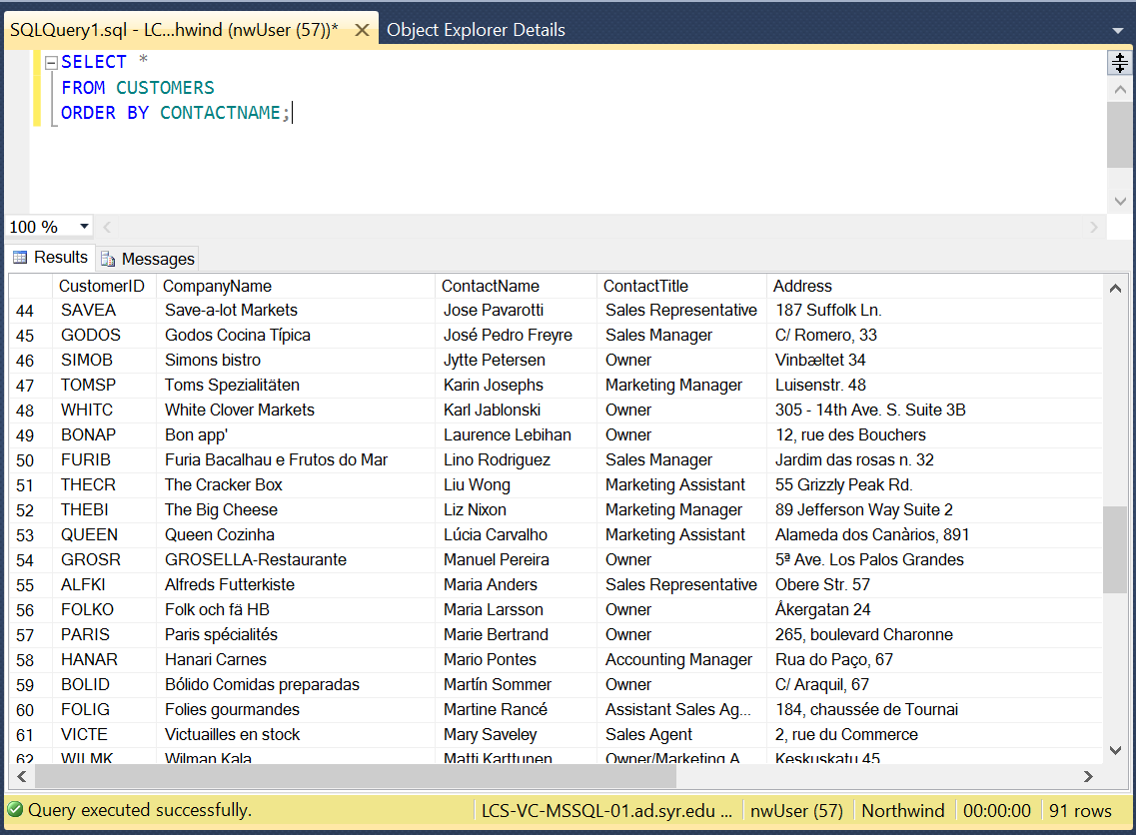

1. Select all data from the Orders table, ordered by OrderDate, oldest date on top.

SELECT *

FROM ORDERS

ORDER BY ORDERDATE ASC;

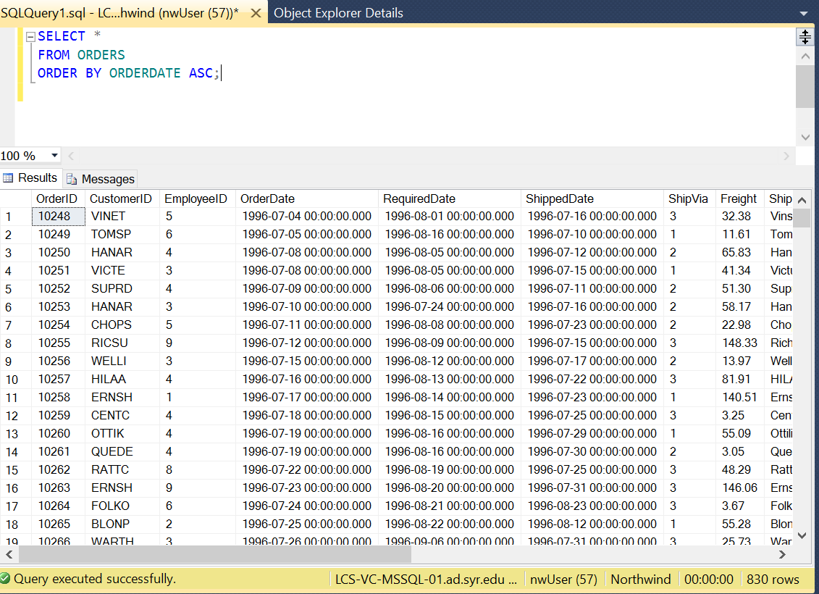

1. Select all data from the Orders table, ordered by ShippedDate, newest date on top.

SELECT *

FROM ORDERS

ORDER BY Shippeddate desc;

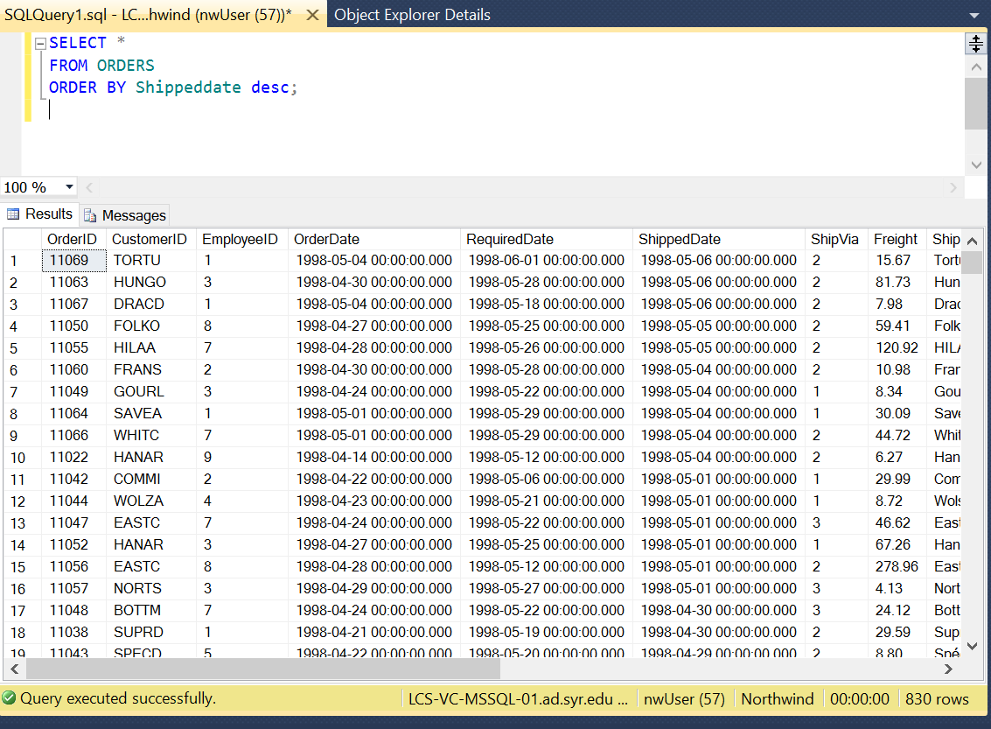

1. Select all data from the Orders table, where order has not shipped yet (ShippedDate is null).

SELECT *

FROM ORDERS

where shippeddate is null;

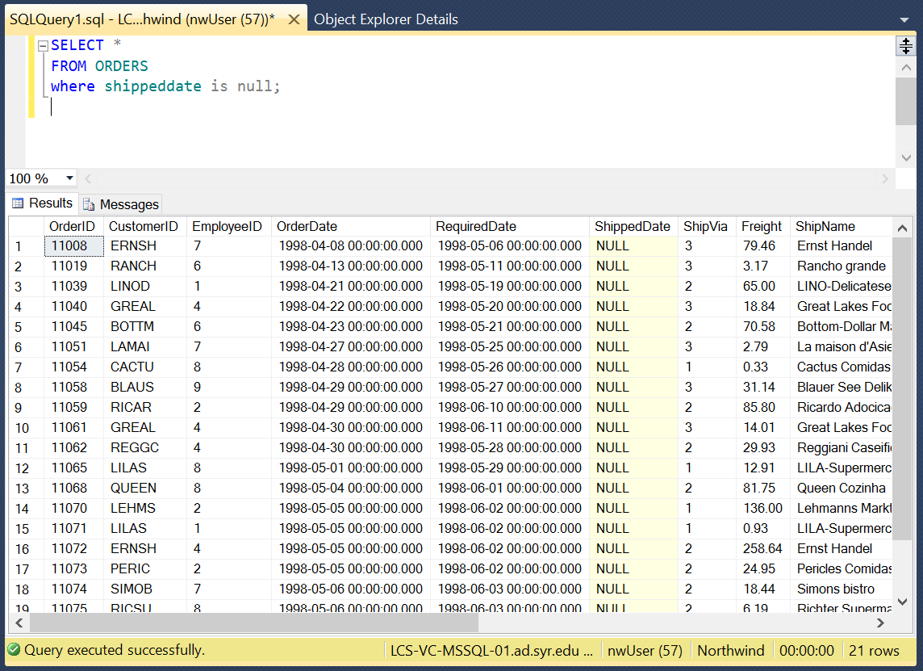

1. Select CompanyName, ContactName and ContactTitle from the Customers table, where Company Name starts with D.

SELECT CompanyName, ContactName, ContactTitle

from customers

where CompanyName like 'D%';

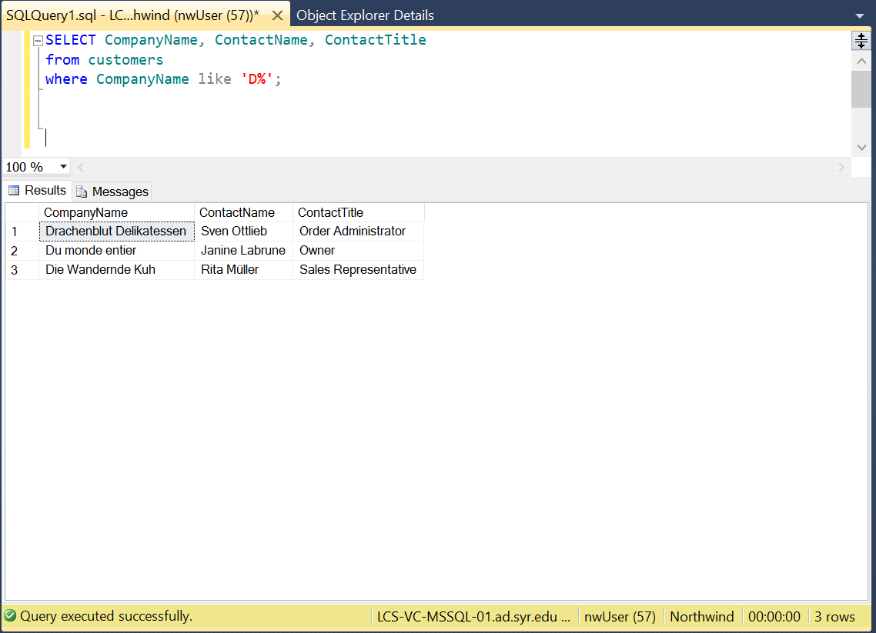

1. Select EmployeeID, FirstName, LastName and Title from the Employees table, where last name starts with D, E or F.

SELECT EmployeeID, FirstName, LastName

from employees

WHERE LastName like 'D%'

OR LastName like 'E%'

OR LastName like 'F%';

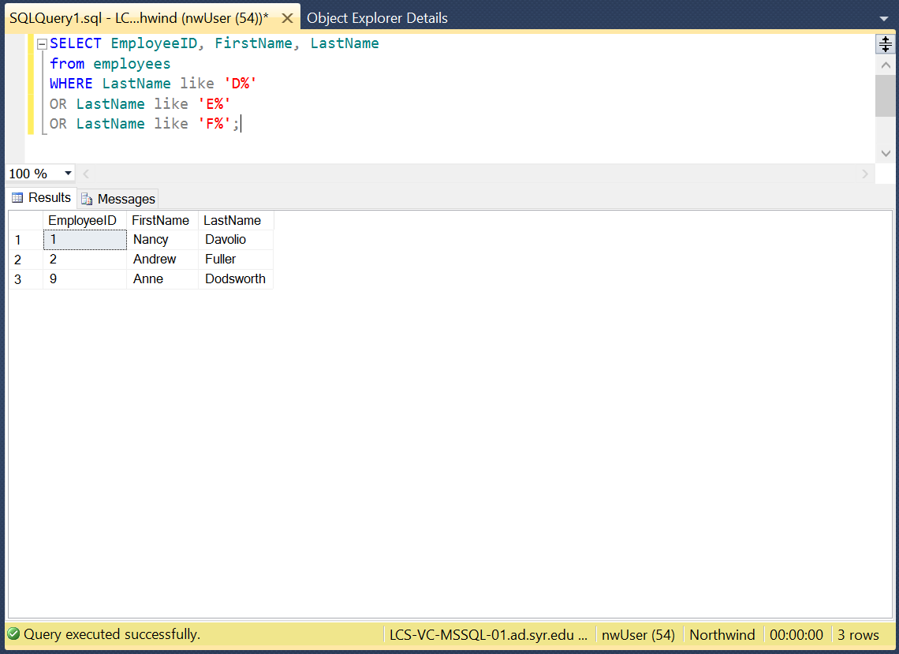

1. Select number of records from the Suppliers table. *=> Result should be a single cell containing a single number (however many digits is appropriate).*

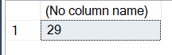

SELECT count(*)

from suppliers;

